

West Coast Collaborative
Specialist Mathematics Investigation 2
Vector Product (Cross Product)
In Class Validation

Scientific and/or Approved Graphic Calculators but no notes allowed in the validation. Mobile phones must be switched off and in bags.

Name: _______________________________
Answer all questions in the spaces provided and provide full working to justify your answers.

Time allowed : 50 minutes Maximum marks = 47

The definitions reproduced below are for your reference:

The vector product or cross product of two vectors a and b is a vector v which is written as: v = a x b and is defined as follows:

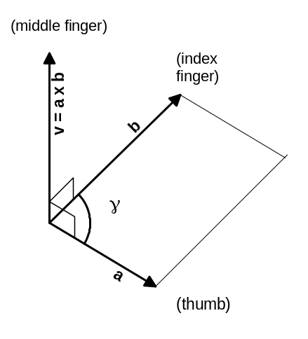If a and b have the same or opposite direction or either a or b is zero then v = a x b = 0, otherwise;

v = a x b is the vector whose length is equal to the area of the parallelogram with a and b as adjacent sides and whose direction is perpendicular to both a and b and is such that a, b, v, in this order, form a right-handed triple or right handed triad, as shown in the diagram.

The term right-handed is derived from the fact that the vectors a, b, v, in this order, assume the same orientation as the thumb, index finger and middle finger of the right hand when held as indicated in the diagram.

The parallelogram with a and b as adjacent sides has the area 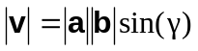
Where γ is the angle between a and b.
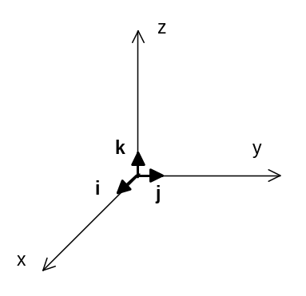
Suppose that the vectors a, b, and v are represented in component form with respect to a right-handed, three dimensional Cartesian coordinate system, with unit vectors i, j and k in the directions x, y and z respectively.

Let 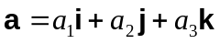 and 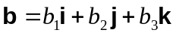
Then

Finally, if v = a x b , and the component vectors of v are v₁, v₂ and v₃, then the magnitude of v is |v| = |v₁i + v₂j+ v₃k|

where 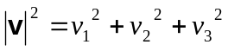
QUESTION 1 [ 1 Mark ]

Is i x j a scalar or a vector quantity? ANSWER:

QUESTION 2 [ 5, 1, 5, 2 Marks ]

If, a = 2i + 3j - 5k, b = i + 4j – k and c = 2i + 2j + 5k then determine the following, showing full working of each element of the calculation, where appropriate:

2a) a x b | 2b) b x a
2c) a x c | 2d) |a x c|, exactly

QUESTION 3 [ 7, 7 Marks ]

Determine the exact area to three decimal places of the parallelogram, of which the given vectors are adjacent sides. Show full working for each set of calculations.

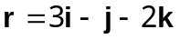, s = 4i + 5j – 2k , by two different methods.

Method 1, using the cross product

Method 2, using the dot product

QUESTION 4 [ 7,3 Marks ]

a) For the vectors a and b, such that a =< 11, 2, -9 > and b = < -1, 5, -6 >,
Show that the cross product a x b is perpendicular to both vectors a and b.
Show full working for your calculations.

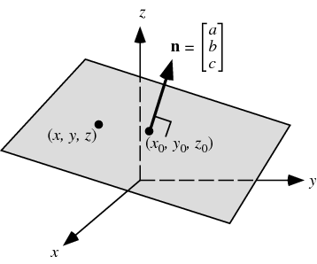
b) In the same way a vector equation in two dimensions can be defined by the normal to that vector, in three dimensions a plane can be defined by applying the normal to the vectors on the plane to any point on the plane.

It is defined by r.n = a.n
where a is the position vector of a point on the plane

If the point p = 3i – 4j – k lies on the plane containing both a and b, state the equation of the plane.

QUESTION 5 [ 3 Marks ]

If a x b = 9k and 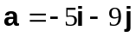 and 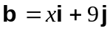, then determine the value of .
QUESTION 6 [ 5, 1 Marks ]

a) Let and . Prove that 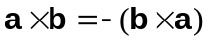
by expanding both sides of the equation.

b) Given that , sketch b x a in the following drawing:
